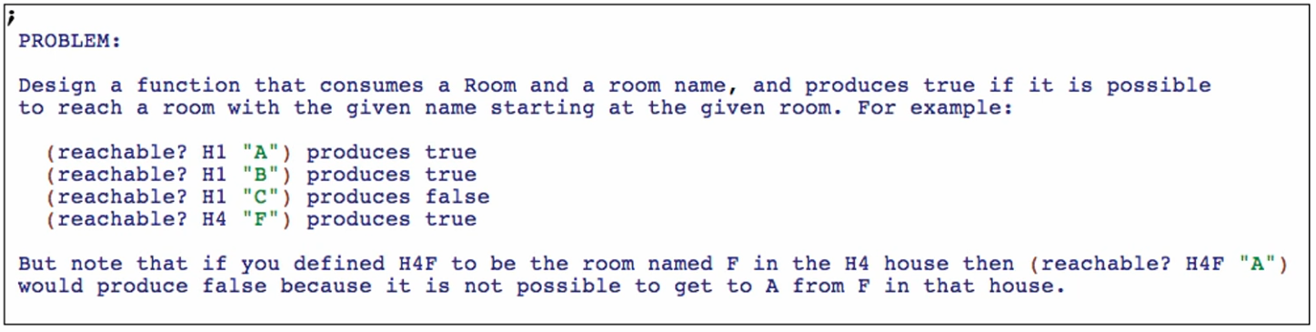

Function definition

**Signature, purpose, and stub**

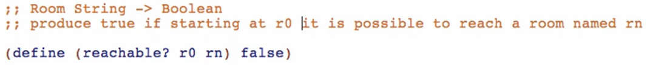

**Examples**

Start with the free ones (from the problem statement)

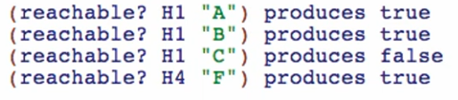

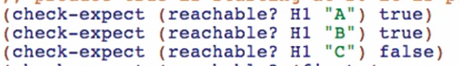

Now let’s start from the room B and ask if A is reachable from B:





**Template**

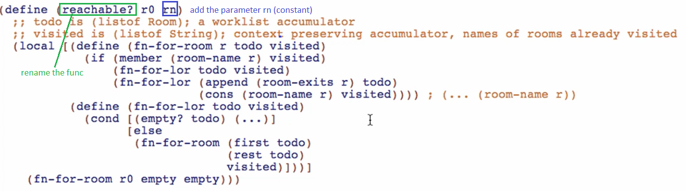

rn is a constant so we don’t have to add it as a parameter in the (…) or in the function body template

**Code Body**

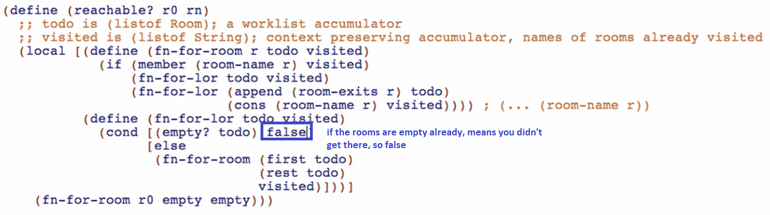

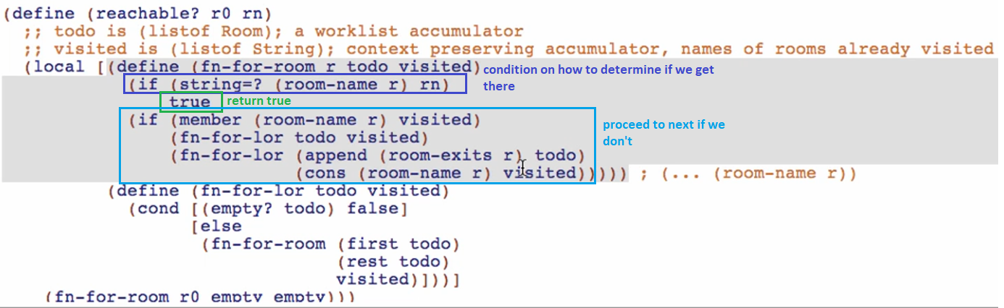

We can rewrite the doubly nested if with a cond:

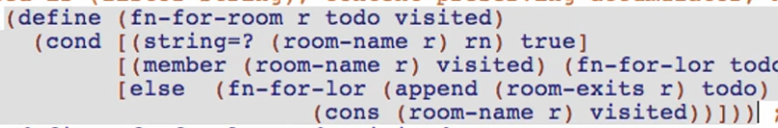

Run and debug!

